October 17, 2017

**SURGERY ON SUNDAY**

INCEPTION SPECIFICATIONS DOCUMENTS

KAYLEE THOMAS, MARIAH SKEETERS, GARRETT DIEBOLD,

JESSICA HOFFMAN, DAMON QUIRE, LIZBETH ROBLES

**QUALITY CONTROL**

**Table of Contents**

**System Request…………………………………………………………………………………………………………………………………4**

**Vision Document................................................................................................................................6**

**1. Introduction ...............................................................................................................................6**

**1.1 References ..........................................................................................................................6**

**2. Positioning .................................................................................................................................6**

**2.1 Problem Statement.............................................................................................................6**

**2.2 Product Position Statement.................................................................................................7**

**3. Stakeholder and User Descriptions .............................................................................................7**

**3.1 Stakeholder Summary.........................................................................................................7**

**3.2 User Summary ....................................................................................................................7**

**3.3 User Environment ...............................................................................................................8**

**3.4 Summary of Key Stakeholder or User Needs ....................................................................... 8**

**3.5 Alternatives and Competition ............................................................................................. 8**

**4. Product Overview ...................................................................................................................... 8**

**4.1 Product Perspective ........................................................................................................... 8**

**4.2 Assumptions and Dependencies.......................................................................................... 8**

**5. Product Features ....................................................................................................................... 9**

**6. Other Product Requirements ......................................................................................................9**

**6.1 Applicable Standards...........................................................................................................9**

**Appendix A........................................................................................................................................10**

**7. Feasibility Considerations ...........................................................................................................10**

**7.1 Technical Feasibility ............................................................................................................10**

**7.2 Operational Feasibility........................................................................................................ 11**

**7.3 Economic Feasibility........................................................................................................... 12**

**Process Models ……………………………………………………………………………………………………………………………….15**

**As-Is Process Model ……………………………………………………………………………………………………………..15**

**To-Be Process Model……………………………………………………………………………………………………………..17**

**System Requirements ...................................................................................................................... 19**

**1. Functional Risks.................................................................................................................. 19**

**2. Non-functional ................................................................................................................... 23**

**Use Cases ........................................................................................................................................24**

**Trace Matrix ....................................................................................................................................28**

**Initial Architecture Considerations ....................................................................................................30**

**1. Design Viewpoint......................................................................................................................30**

**2. Realization Viewpoint...............................................................................................................31**

**Risk Analysis ....................................................................................................................................32**

**Criteria used to assess risk:........................................................................................................32**

**Team Charter....................................................................................................................................33**

**Gantt Chart........................................................................................................................................36**

**Inception Phase Prototypes .............................................................................................................. 37**

**1. Dynamic Volunteer Form .......................................................................................................... 37**

**2. Events/Media Page ...................................................................................................................38**

**3. Braintree Donations.................................................................................................................. 39**

**4. Homepage ...............................................................................................................................40**

**5. Administration Portal................................................................................................................ 41**

System Request – Surgery on Sunday Louisville

The system request is used to evaluate the opportunity given to improve Surgery on Sunday’s current database system and the value that it is expected to provide. The system request will address the project sponsor, expected business need, business requirements, business value, and the issues and constraints that occur.

**Project Sponsor:**  
Barbara Martin, Program Coordinator  
Jordan Licata, IT Coordinator  
Erica Sutton, MD, President and CEO

**Business Need:**   
This project has been initiated to improve the business processes of Surgery on Sunday Louisville. Currently, their business processes require several manual steps that are time-consuming and inefficient. Many of these manual processes can be automated to save time, money, and allow resources to be used more effectively.  
  
**Business Requirements:**  
Using the Surgery on Sunday Website, visitors should be able to navigate the site easily. Potential volunteers should be able to sign-up through the use of dynamic forms and have their information sent to a centralized location. Donors should be able to make donations on the website easily and the donor information should be collected efficiently and sent to a centralized location for future retrieval. The Functionality that the system should have is as follows:

* The Website should allow potential volunteers to sign-up with the use of dynamic forms. These forms will help organize volunteer information and categorize volunteers as clinical or nonclinical volunteers. This improvement will assist and improve the event scheduling process
* Donors should be able to locate donation links or buttons quickly and easily. The donation process must be easy for the potential donor and allow different payment options.

**Business Value:**  
We expect that Surgery on Sunday Louisville will see increases in donations by increasing the payment options for donations and by reaching out to previous donors. We also expect to see increases in returning clinical and nonclinical volunteers with the use of a more efficient data collection and tracking process. We expect the improved process will bring back former volunteers and donors. Surgery on Sunday should benefit from improved business processes.  
Conservative estimates of tangible value to the non-profit organization include:

* 50 - 60% reduction in time for scheduling events and pulling reports (spend 8 - 10 hours on event scheduling as opposed to the current 35 hours spent per week)
* 10% increase in donations ($1,428.22 more donations per year)

**Special Issues or Constraints:**

* The system should be in place at the end of the Spring 2018 semester
* Federal Tort Claims Act (FTCA) requires disclosure of all clinical and non-clinical volunteers
* Health Insurance Portability and Accountability Act (HIPAA) and health information privacy

Vision Document

# **Introduction**

The purpose of this document is to collect, analyze, and define high-level needs and features of the Surgery on Sunday Louisville System. It focuses on the capabilities needed by the stakeholders and the target users, and why these needs exist. The details of how the Surgery on Sunday Louisville System fulfills these needs are detailed in the use-case and supplementary specifications.

The introduction of the Vision document provides an overview of the entire document. It includes the purpose and references of this Vision document.

## **References**

**1.2** Surgery on Sunday Louisville Website

<http://www.soslouisville.org/>

* 1. Please refer to Appendix A for the feasibility analysis related to this system.

# **2. Positioning**

## **2.1 Problem Statement**

Currently Surgery on Sunday Louisville’s business processes depend on manual steps to collect and organize information for reporting, decision making, and event scheduling.  The current volunteer sign-up process has users submit forms which are stored in an Excel File in the organization’s Google Drive. This results in the duplicate information being stored. The program coordinator then has to sift through all the rows of data to remove duplicate information in order to manipulate the data for reports. The current donation process is also a manual process that is time-consuming for the program coordinator because donor and donation information has to be manually keyed into a spreadsheet, this could result in inconsistent data.

|  |  |
| --- | --- |
| The problem of | Inefficient data collection process and manual processes |
| affects | Patients, volunteers, donors, and the organization employees |
| the impact of which is | Time-consuming processes event scheduling, loss of important information, increase in redundant data and data inconsistencies |
| a successful solution would be | An efficient donor and volunteer data collection and tracking process would allow for a more efficient event scheduling process. This would save time and allow the program coordinator to spend more time on other important tasks, such as writing grants. |

## **Product Position Statement**

|  |  |
| --- | --- |
| For | Patients, current and potential volunteers and donors, |
| Who | are interested in learning more about the organization’s mission and are interested in donating their time and money |
| The Surgery on Sunday Louisville System | is an improved Website |
| That | Will reduce time spent on manual processes that can be automated, and will improve the data collection process to coordinate surgical events more efficiently and effectively. |
| Unlike | Current website that |
| Our product | Will improve the business processes of the organization and will allow the organization to use their resources more effectively. |

# **Stakeholder and User Descriptions**

## **Stakeholder Summary**

|  |  |  |
| --- | --- | --- |
| **Name** | **Description** | **Responsibilities** |
| Program Coordinator | This stakeholder works with clinical and non-clinical volunteers to match them to surgical events. | This stakeholder writes grants to increase revenues (donations) for the organization. Analyzes volunteer information for decision making and to coordinate 10-12 surgical events per year. Provides administrative support for the organization. |
| Technology coordinator | This stakeholder works with the program coordinator and provides tech-related support for the organization. | This stakeholder provides tech-related support for the organization. Has implemented the use of automated forms for volunteer recruitment to improve the volunteer recruitment process. |

## **User Summary**

|  |  |  |  |
| --- | --- | --- | --- |
| **Name** | **Description** | **Responsibilities** | **Stakeholder** |
| Volunteers  Clinical and Non-clinical | End user of the system | Uses Website to submit their applications. Physicians use the site to refer patients. Potential volunteers use the site to learn more about the organization. | Self |
| Donors | End user of the system | Uses Website to make donations and potential donors use the site to learn more about the organization. | Self |
| Patients | End user of the system | Uses the site to learn more about the organization and resources that are available to them. Uses the site for application process. | Self |

* 1. **User Environment**

The users interacting with the back end of the system are the admin staff at SOS and the IT coordinator. The users interacting with the front end of the system are patients, donors, doctors, and volunteers.

**3.4 Summary of Key Stakeholder or User Needs**

|  |  |  |
| --- | --- | --- |
| **Problem** | **Current Solution** | **Proposed Solution** |
| Lack of data integration | Google Forms are used to input data into an excel spreadsheet | Design a database with forms that directly input data |
| Lack of donor tracking | Information is collected through PayPal when donation is made but SOS does not directly collect specific data | Redirect donor information to database with necessary fields |
| Untailored volunteer categories | Medically trained volunteers are not classified as “non-clinical” | Reclassify and create required fields for medically trained volunteer credentials |
| Disorganized methods of contact | E-mails are sent manually and irregularly | Incorporate email system with database to ease contact efforts for all involved parties for regular e-mail blasts and reliable correspondence |

* 1. **Summary of Key Stakeholder or User Needs**

As a not-for profit organization SOS does not have direct competitors when it comes to patients. Their competition is organizations who recruit medical personnel to help those in need and the volunteers that help run events. SOS is more at risk for losing that group to other organizations which will hinder their operations

**4. Product Overview**

**4.1 Product Perspective**

This product is independent and self-contained. There are not any other systems that need to be implemented within the organization.

**4.2 Assumptions and Dependencies**

* SOS will gain access to secure data portal that is HIPAA compliant
* Administrators will be able to be trained to maintain and utilize system
* System will be more user-friendly

**5. Product Features**

* Integrated database
* Automated form entry
* Dynamic forms
* Enhanced payment options
* Email system
* Tailored data collection
* Social media portals
* Automate event scheduling

**6. Other Product Requirements**

**6.1 Applicable Standards**

SOS Louisville must comply with HIPAA regulations. The FTCA also requires disclosure on all SOS Louisville clinical and nonclinical volunteers.

Appendix A

**7. Feasibility Considerations**

There are five technical concerns within the organization that need to be addressed. These include the following: acquiring information from volunteers (clinical and nonclinical), donor tracking, data integration, manual data retrieval, and manual event scheduling.

**7.1 Technical Feasibility**

Outlined below are the technical feasibilities and benefits of implementing a more streamlined database.

* Data integration

o This is the largest issue that the client faces. Multiple technical concerns could be addressed with a relational database. This could integrate all the data to work together and allow the client to simply retrieve data when needed from one centralized location. Possible solutions would be Access and the database within WordPress. An Access database is currently priced at $109.99. This is relatively cheap considering this would be a one-time fee. The only issue with this solution is that the database would be integrated directly to their website. An additional product would need to be purchased to work together cohesively. Another option would be to use the database that is installed in the back end of WordPress. This uses php MyAdmin as a plug-in to better manage the database. This option would be free to use and need little technical training for employees.

• Acquiring information from volunteers (clinical and nonclinical) and manual data retrieval

o Currently it takes Surgery on Sunday approximately 30 hours per week to manually enter non-clinical volunteer information. In addition to that, manually entering doctor information consumes approximately 5 hours per week. If we were to implement a relational database, such as Access or the database on the back-end of WordPress, we could eliminate manually entry which would save them 35 hours per week in total. This would save the organization 140 hours per month (35 hours × 4 weeks). The time saved could be better utilized by making time for additional fundraising activities to bring in a potential $7,000 in fundraising revenue (see details in economic feasibility section below).

• Manual event scheduling

o Currently the client does not have a system that can match doctors to potential patients. This leads to manual entry of doctor-patient matching for event scheduling. It currently consumes 10 hours a month for this manual process. With a relational database, a potential 40 hours a month could be saved (10 hours per week × 4 weeks). This time could be used to increasing the number of events that are held per month. Currently, SOS (Surgery on Sunday) holds 1 event per month. With additional time and a more efficient system to match patients and doctors, they would have more time to increase the number of events by a conservative 40% (4 additional events per year).

o Currently SOS has 62 doctors and holds 12 events per year. They have enough doctors to potentially have 5 doctors per surgery. With a relational database to better utilize doctors time by matching them with a corresponding patient could lead to more surgical events. With the current number of doctors on staff SOS could potentially double the number of surgical events per year.

• Donor tracking

o The client would like to better track the donor attendance to send appreciate letters and donation hour confirmation. If the client were to implement MailMunch, which is a free program within WordPress, they could send out monthly e-mails to their list of donors. This would cost the client no additional hours in labor, because the database will do this for them. The relational database can keep track of both monetary and time donations for better donor tracking. The client could then pull the data from the database to get the information needed.

**7.2 Operational Feasibility**

Next, we will look at the organizational feasibility. This has to do with how we will implement the system and how well the users will respond into the ongoing organization.

• Our goal is not to make any changes that would be difficult for current employees to adjust to. We are striving to make the process run smoothly without much change on the user’s end. This means there would be little to no additional training for current employees.

• The relational database system will be used to address the concerns of the client and more. This is used to make the business operate more efficiently and easier to adjust to possible growth within the company.

**7.3 Economic Feasibility**

Below are the economical feasibilities for the project with a cost/benefit analysis.

• Online payment processing

o Currently the company utilizes PayPal as their current online payment processor. They charge a 2.9% + $0.30 per transaction fee, but do not charge setup fees or monthly fees. There are two additional payment processors to consider, Dwolla and BrainTree.

o Using Dwolla, we will use an example of 5 transactions of $10 and 10 transactions of $100. Below are the calculations that show a potential savings of $340.80 per year. Dwolla has no fees for transactions less than $10 and anything over $10 has a $0.25 fee per transaction.

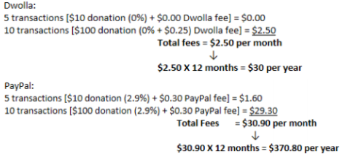



o BrainTree is a branch of PayPal. Currently their transaction fees are the same, but has customer satisfaction different. PayPal is known to have hidden fees for cards such as American Express and foreign transactions. The biggest difference is with customer service. There is higher customer satisfaction with BrainTree over PayPal. While there would not be any potential savings with this option there is possibility for additional revenue. BrainTree does offer recurring billing which could be utilized for donators that would like to just donate monthly and it pulls the money for them rather than them having to manually enter information.

• Additional revenue possibilities

o Grants

▪ Currently SOS has 5 grants that total to $146,900. With a more centralized database, more grants would be written due to easy access to information. Below is an illustration that shows the potential grant revenue of $58,760 with the average grant being $29,380. This is a conservative number of 2 additional grants.



o Donations

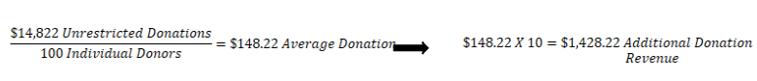▪ Currently SOS has 100 individual donors that total to $14,822 in donor revenue. With a more centralized database and change of online payment platform, more donations are possible. Below is an illustration that shows the potential donation revenue of $1,428.22 with the average donation being $148.22. This is a probable number of a 10% increase in donations.

o Fundraisers

▪ Currently SOS only hold one annual fundraiser per year. This fundraiser produces approximately $7,000 in revenue. With the time saved (detailed above in technical feasibility section), SOS would have more time to organize fundraising events. With a conservative viewpoint, fundraising events could increase by 1 additional event per year. This could lead to an additional revenue of $7,000.

o In totality, this could be an additional $68,188.22 per year for Surgery on Sunday.

• Marketing concerns

o To gain the additional fundraising and donation revenue, SOS should consider revamping their digital marketing. Currently the client has an events page and events page. If they were to implement social media portals, testimonials, and documentation of their events, they could reach a wider audience which in turn could benefit to higher revenues and helping more people.

Finally, we will look at the organizational feasibility. This has to do with how we will implement the system and how well the users will respond into the ongoing organization.

• Our goal is not to make any changes that would be difficult for current employees to adjust to. We are striving to make the process run smoothly without much change on the user’s end. This means there would be little to no additional training for current employees.

• The relational database system will be used to address the concerns of the client and more. This is used to make the business operate more efficiently and easier to adjust to possible growth within the company.

* Summary and Cost/Benefit Analysis

Explained above are the numerous benefits provided by the system. Table 1 below further demonstrates the impact of these benefits and the outlined costs that are minimal in comparison. The developmental costs are salaries of the professionals responsible for the coordination and design of the system, as well as the annual costs incurred for maintenance and website fees. The anticipated costs and benefits have been outlined below in a NPV (net present value) analysis using the following figures:

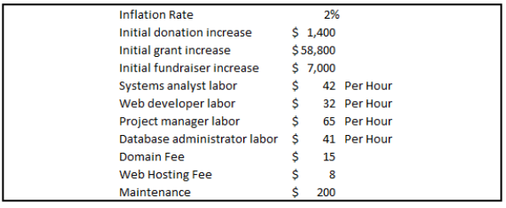

The project will bring in a return on investment of 3748% with an expected NPV of $271,382. These numbers would suggest that the projected earnings greatly exceed the anticipated costs. This concludes that it is economically feasible to invest in creating a new system for Surgery on Sunday.

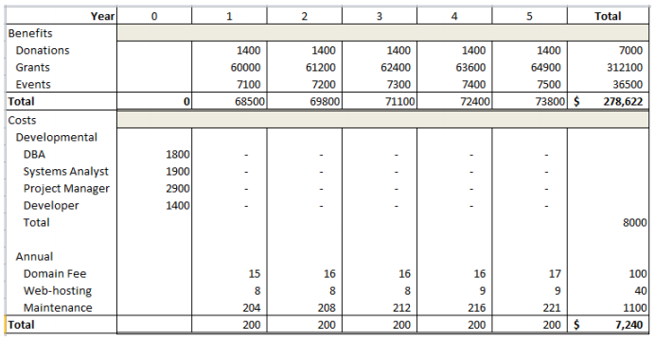

Process Models

**As-Is Process Model**

The diagram below depicts the current process model of Surgery on Sunday Louisville’s major business processes. These processes include acquiring volunteers, managing patient referrals, raising funds through grants and donations, and facilitating surgical events.

In order to gain new volunteers, SOS Louisville’s website has an online form for signing up. When the form is submitted, it is stored as an Excel spreadsheet directly into Google Drive. This method does not prevent duplicate or inconsistent data because cells and rows in Excel don’t have to be unique or validated by business rules and requirements. When volunteers need to be contacted to organize an event, the SOS coordinator has to manually look through the Excel files.

When a doctor wants to submit a patient referral to Surgery on Sunday Louisville, patients must have their Primary Care Provider access the online form with a secure password provided by SOS. The submitted form is stored directly into U of L’s Redcap database, which is HIPAA compliant and expected to be replaced by Epic Connect. Redcap doesn’t use a relational database model; it is more like spreadsheets. Changing this functionality is out of scope for our project due to the restrictions placed by HIPAA. Something that isn’t out of scope is improving the referral form itself, which has limited categories and inputs that would be necessary to take proper care of the patient.

The surgical events are made possible through donations to SOS. To make a donation through their website, a donor is redirected to a form that needs some improvement to encourage donations. Unfortunately, the donor’s information such as name and contact phone number are manually keyed into an Excel spreadsheet, which does not go directly into Google Drive like the Volunteer signup form. The donation amount is charged a considerable fee by PayPal and then deposited into SOS’s account.

Each of the business processes require several manual steps before any data can be used together for decision-making and scheduling surgeries. At such events, the volunteer attendance has been recorded on paper. It is likely that the hard-copy information is used to manually update the Excel spreadsheet containing that volunteer’s data. Since the data isn’t centralized, it is difficult to generate reports that are used to write grants. The data for writing grants must be manually retrieved each time by sifting through various spreadsheets.

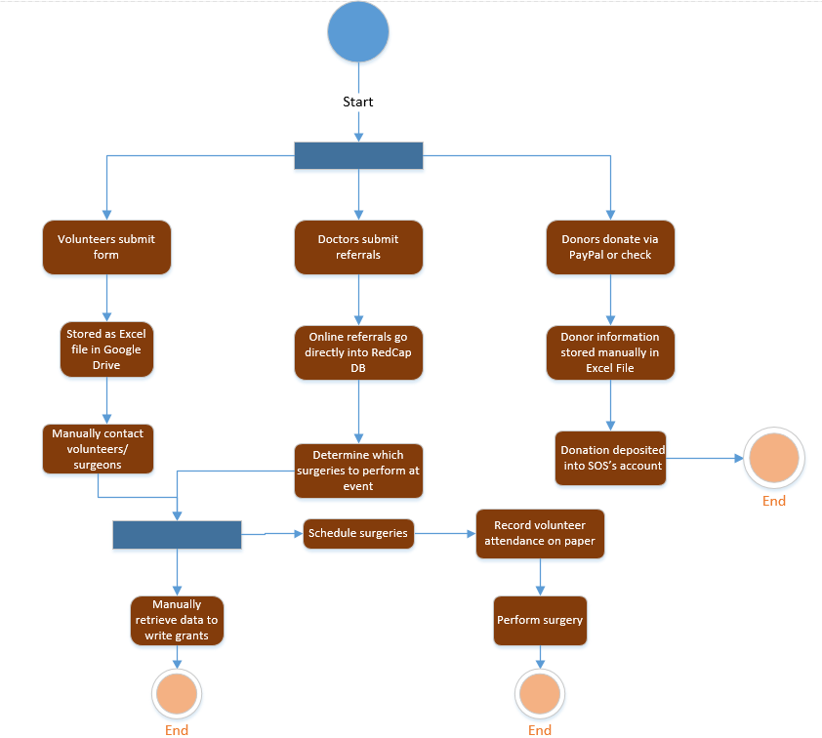

**To-Be Process Model**

The diagram below shows the prospective future process model for Surgery on Sunday Louisville’s business processes. These include acquiring volunteers, managing patient referrals, raising funds through grants and donations, and finally holding surgical events.

        When a volunteer registers on SOS Louisville’s website through an online form, it would be useful to auto-gather that information. This information, once gathered from the website, will be stored in a central database that holds volunteer information that will be subdivided into multiple categories such as doctors, nurses, medical translators, medical support staff, and non-clinical volunteers. When a volunteer checks in at any event that information will auto-update that volunteer’s file without redundancy. This will be useful for keeping track of donor involvement and sending them personalized thank you letters. In addition, having a relational database will help tremendously with auto-scheduling volunteers to surgical events and otherwise.

        Patient information is under the protection of HIPAA and therefore will not be very much affected by our project. However, it would be beneficial for SOS Louisville if we changed the patient referral form to be more inclusive of transgendered patients, ensuring that they receive the proper care they need. It is outside of the scope of our project, but it would also be beneficial if SOS Louisville could migrate their patient database to a more relational model that could better keep track of patient information.

        Since SOS Louisville is a not-for-profit, donations and grants keep the organization afloat. Much like the volunteer forms, it would be useful to auto-gather donor information from SOS Louisville’s website. Once this information is collected, it too will be stored in a relational database that can keep track of donor engagement. This information can be used to send newsletters, invites to fundraising events, and once again to send personalized thank you letters. Also, it would be useful to have a relational database just to make the process of writing and receiving grants easier than it currently is. With a relational database, the person writing the grants can perform queries on needed data instead of combing through excel sheets scattered across the organization.

        As stated previously, it would be much easier to auto-schedule surgical events with a relational database than it would be to comb through several excel spreadsheets. With the envisioned system, SOS Louisville could auto-match volunteers to surgeries based on patient needs.

        Essentially, the prospective future process model looks to store data in a more centralized manner, and to provide more form options for prospective patients. This can be useful for simplifying all of SOS Louisville’s business processes by providing them a way to automate their processes.

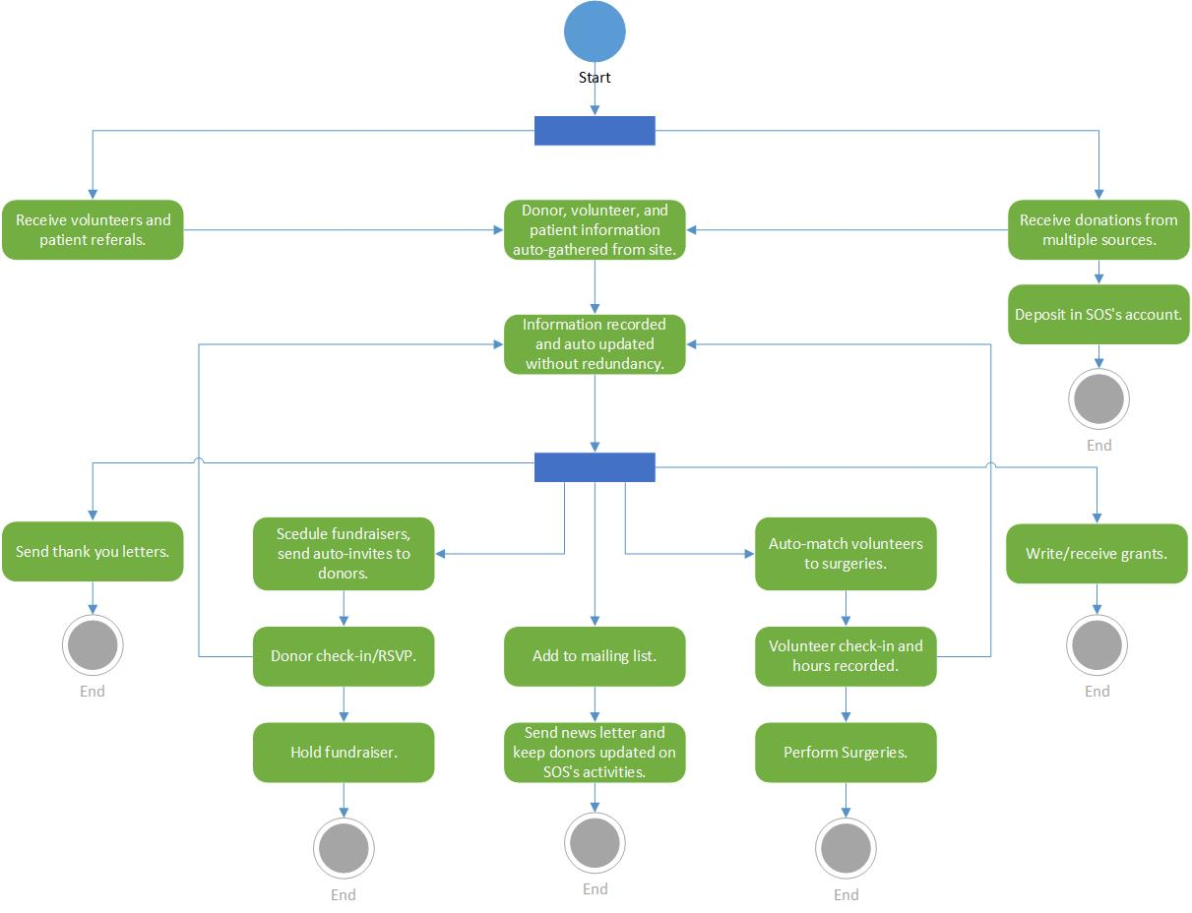

System Requirements

System requirements are the functional and non-functional components of a system. These requirements are necessary for the system to perform desired business processes effectively.

Functional requirements are defined as the physical components within the system. Nonfunctional requirements are defined as the virtual components within the system

**1. Functional Risks**

**Donors**

|  |  |  |
| --- | --- | --- |
| **ID** | **Requirement** | **Risk** |
| **01** | The new system will allow users to insert donor records into the database | **High** |
| **02** | The new system will allow users to update donor records | **High** |
| **03** | The new system will allow users to delete donor records | **Low** |
| **04** | The new system will automatically insert donor records when donations are submitted online | **Medium** |
| **05** | The new system will utilize a user-friendly payment system for donations | **Medium** |
| **06** | The new system will allow for donations by card | **Low** |
| **07** | The new system will automatically deposit new donations into SOS bank account | **High** |
| **08** | The new system will provide reports about donors | **Medium** |
| **09** | The new system will provide reports about donations | **Medium** |
| **10** | The new system will send automated emails thanking donors | **Low** |
| **11** | The new system will send newsletter emails to donors to keep them informed | **Low** |

**Surgeons**

|  |  |  |
| --- | --- | --- |
| **10** | The new system will allow users to insert surgeon records into the database | **High** |
| **11** | The new system will allow users to update surgeon records | **High** |
| **12** | The new system will allow users to delete surgeon records | **Low** |
| **13** | The new system will use dynamic forms to capture additional information specific to surgeons | **Medium** |
| **14** | The new system will store information about surgeon licenses | **Low** |
| **15** | The new system will provide reports about surgeons | **Medium** |
| **16** | The new system will send automated emails to a surgeon scheduled for an event | **Low** |
| **17** | The new system will allow users to easily match surgeons to surgical events | **High** |
| **18** | The new system will send emails to thank surgeons | **Low** |

**Nurses**

|  |  |  |
| --- | --- | --- |
| **19** | The new system will allow users to insert nurse records into the database | **High** |
| **20** | The new system will allow users to update nurse records | **High** |
| **21** | The new system will allow users to delete nurse records | **Low** |
| **22** | The new system will use dynamic forms to capture additional information specific to nurses | **Medium** |
| **23** | The new system will store information about nurse licenses (if applicable) | **Low** |
| **24** | The new system will provide reports about nurses | **Medium** |
| **25** | The new system will send automated emails to a nurse scheduled for an event | **Low** |
| **26** | The new system will allow users to easily match nurses to surgical events | **High** |
| **27** | The new system will send emails to thank nurses | **Low** |

**Clinical language interpreters**

|  |  |  |
| --- | --- | --- |
| **28** | The new system will allow users to insert interpreter records into the database | **High** |
| **29** | The new system will allow users to update interpreter records | **High** |
| **30** | The new system will allow users to delete nurse records | **Low** |
| **31** | The new system will use dynamic forms to capture additional information specific to interpreters | **Medium** |
| **32** | The new system will store information about interpreter licenses (if applicable) | **Low** |
| **33** | The new system will provide reports about interpreters | **Medium** |
| **34** | The new system will send automated emails to a interpreter scheduled for an event | **Low** |
| **35** | The new system will allow users to easily match interpreters to surgical events | **High** |
| **36** | The new system will send emails to thank clinical language interpreters | **Low** |

**Non-clinical volunteers**

|  |  |  |
| --- | --- | --- |
| **37** | The new system will allow users to insert non-clinical volunteer records into the database | **High** |
| **38** | The new system will allow users to update volunteer records | **High** |
| **39** | The new system will allow users to delete volunteer records | **Low** |
| **40** | The new system will use dynamic forms to capture additional information specific to non-clinical volunteers | **Medium** |
| **41** | The new system will provide reports about volunteers | **Medium** |
| **42** | The new system will send automated emails to a volunteer scheduled for an event | **Low** |
| **43** | The new system will allow users to easily match volunteers to surgical events | **High** |
| **44** | The new system will send emails to thank volunteers | **Low** |

**Events**

|  |  |  |
| --- | --- | --- |
| **45** | The new system will allow users to insert event records into the database | **High** |
| **46** | The new system will allow users to update event records | **High** |
| **47** | The new system will allow users to delete event records | **Low** |
| **48** | The new system will provide reports about events | **Medium** |
| **49** | The new system will manage volunteer attendance for events | **Medium** |

**Referrals**

|  |  |  |
| --- | --- | --- |
| **50** | The new system will capture additional data about patients on the referral form | **Medium** |
| **51** | The new system will include instructions for getting access to referral form | **Low** |
| **52** | The new system will use dynamic forms to capture additional information | **Low** |
| **53** | The new system will provide reports about referrals (if applicable) | **Medium** |
| **54** | The new system will email SOS coordinators when a new referral has been submitted | **Low** |

**2. Non-functional Risks**

**Availability**

|  |  |  |
| --- | --- | --- |
| **55** | The new system will be available every day | **High** |
| **56** | The new system will not crash if website traffic increases | **High** |
| **57** | The new system’s website will be available to the public | **High** |
| **58** | The new system will be in place by the end of Spring 2018, unless otherwise stated | **Medium** |

**Storage**

|  |  |  |
| --- | --- | --- |
| **59** | The new system’s data storage will be available to SOS coordinators only | **High** |
| **60** | The new system will provide enough data storage | **High** |
| **61** | The new system will use efficient database design and relationships | **Medium** |
| **62** | The new system’s data will be backed up | **High** |

**Maintenance**

|  |  |  |
| --- | --- | --- |
| **62** | The new system will be easy to maintain | **High** |
| **63** | The new system will be thoroughly tested and not break or have bugs | **High** |
| **64** | The new system maintenance will be available to the IT coordinator | **Medium** |

**Constraints**

|  |  |  |
| --- | --- | --- |
| **65** | The new system will not handle sensitive data about patients | **High** |
| **66** | The new system will not violate HIPAA | **High** |
| **67** | The new system will not interface with the RedCap or Epic Connect patient database | **High** |
| **68** | The new system will allow for disclosure of all volunteers, per the Federal Tort Claims Act | **High** |

Use Cases

Use cases represent major business processes the system will perform that benefit the actor(s) in some manner.

|  |  |  |  |
| --- | --- | --- | --- |
| **Case ID** | **Use Cases** | **Primary Actor** | **Brief Description** |
| 1 | AddNewDonor | Executive Director | This use case describes how a donor adds their information when making a donation |
| 2 | UpdateDonorRecords | Executive Director | This use case describes how a user makes changes to donor information |
| 3 | DeleteDonorsRecords | Executive Director | This use case describes how a user deletes donor information |
| 4 | AddDonation | Donor | This use case describes a donor makes a donation |
| 5 | ProcessDonationPayments | Donor | This use case describes how donation payments are processed |
| 6 | DepositNewDonations | Donor | This use case describes how donations are deposited into the SOS bank account |
| 7 | GenerateDonorReports | Executive Director | This use case describes how a user requests reports about donors |
| 8 | GenerateDonationReports | Executive Director | This use case describes how a user requests reports about donations |
| 9 | SendDonorThankYouEmails | Program Coordinator | This use case describes how thank-you emails for donors are emailed |
| 10 | EmailNewsletter | IT Coordinator | This use case describes how newsletters are emailed |
| 11 | AddNewSurgeon | Surgeon | This use case describes how a surgeon's information is added to the system |
| 12 | UpdateSurgeonRecord | Executive Director | This use case describes how a surgeon's information is updated to the system |
| 13 | DeleteSurgeonRecord | Executive Director | This use case describes how a surgeon's information is added to the system |
| 14 | AddSurgeonLicense | Surgeon | This use case describes how surgeon license information is added to the system |
| 15 | GenerateSurgeonReports | Executive Director | This use case describes how a user requests reports about surgeons |
| 16 | SendSurgeonEmails | Program Coordinator | This use case describes how emails are sent to surgeons |
| 17 | SurgeonEventScheduling | Program Coordinator | This use case describes how events with surgeons are scheduled |
| 18 | SendSurgeonThankYouEmails | Program Coordinator | This use case describes how thank-you emails for surgeons are emailed |
| 19 | AddNewNurse | Nurse | This use case describes how a nurse's information is added to the system |
| 20 | UpdateNurseRecord | Executive Director | This use case describes how a nurse's information is updated to the system |
| 21 | DeleteNurseRecord | Executive Director | This use case describes how a nurse's information is deleted from the system |
| 22 | AddNurseLicenses | Nurse | This use case describes how nurse license information is added to the system |
| 23 | GenerateNurseReport | Executive Director | This use case describes how a user requests reports about nurses |
| 24 | SendEmailsToNurses | Program Coordinator | This use case describes how emails are sent to nurses |
| 25 | NurseEventScheduling | Program Coordinator | This use case describes how events with nurses are scheduled |
| 26 | SendNurseThankYouEmails | Program Coordinator | This use case describes how thank-you emails for nurses are emailed |
| 27 | AddNewInterpreter | Clinical language interpreters | This use case describes how an interpreter's information is added to the system |
| 28 | UpdateInterpreterRecord | Executive Director | This use case describes how an interpreter's information is updated to the system |
| 29 | DeleteInterpreterRecord | Executive Director | This use case describes how an interpreter's information is deleted from the system |
| 30 | AddInterpreterLicenses | Clinical Language Interpreters | This use case describes how an interpreter's license information is added to the system |
| 31 | GenerateInterpreterReport | Executive Director | This use case describes how a user requests reports about interpreters |
| 32 | SendEmailsToInterpreters | Program Coordinator | This use case describes how emails are sent to interpreters |
| 33 | InterpreterScheduling | Program Coordinator | This use case describes how events with interpreters are scheduled |
| 34 | SendInterpreterThankYouEmails | Program Coordinator | This use case describes how thank-you emails for interpreters are emailed |
| 35 | AddNewNonClinicalVolunteer | Non-clinical volunteers | This use case describes how a non-clinical volunteer's information is added to the system |
| 36 | UpdateNonClinicalVolunteerRecord | Program Coordinator | This use case describes how a non-clinical volunteer's information is updated to the system |
| 37 | DeleteNonClinicalVolunteerRecord | Program Coordinator | This use case describes how a non-clinical volunteer's information is deleted from the system |
| 38 | GenerateVolunteerReports | Executive Director | This use case describes how a user requests reports about non-clinical volunteers |
| 39 | SendEmailsToVolunteers | Program Coordinator | This use case describes how emails are sent to non-clinical volunteers |
| 40 | GenerateVolunteerEventSchedule | Program Coordinator | This use case describes how events with non-clinical volunteers are scheduled |
| 41 | SendVolunteerThankYouEmails | Program Coordinator | This use case describes how thank-you emails for non-clinical volunteers are emailed |
| 42 | AddNewEvent | Program Coordinator | This use case describes how event information is added to the system |
| 43 | UpdateEventRecord | Program Coordinator | This use case describes how event information is updated to the system |
| 44 | DeleteEventRecord | Program Coordinator | This use case describes how event information is deleted from the system |
| 45 | GenerateEventReports | Executive Director | This use case describes how a user requests reports about events |
| 46 | AddAttendance | Program Coordinator | This use case describes how attendance information is added |
| 47 | AddNewPatient | Doctors | This use case describes how a a new patient from referrals is added to the system |
| 48 | DisplayReferralInstructions | Doctors | This use case describes how referral instructions are displayed |
| 49 | GenerateReferralReports | Executive Director | This use case describes how a user requests reports about referrals |
| 50 | GenerateReferralNotifications | Doctors | This use case describes how referral notifications are generated after a referral is submitted |

Trace Matrix

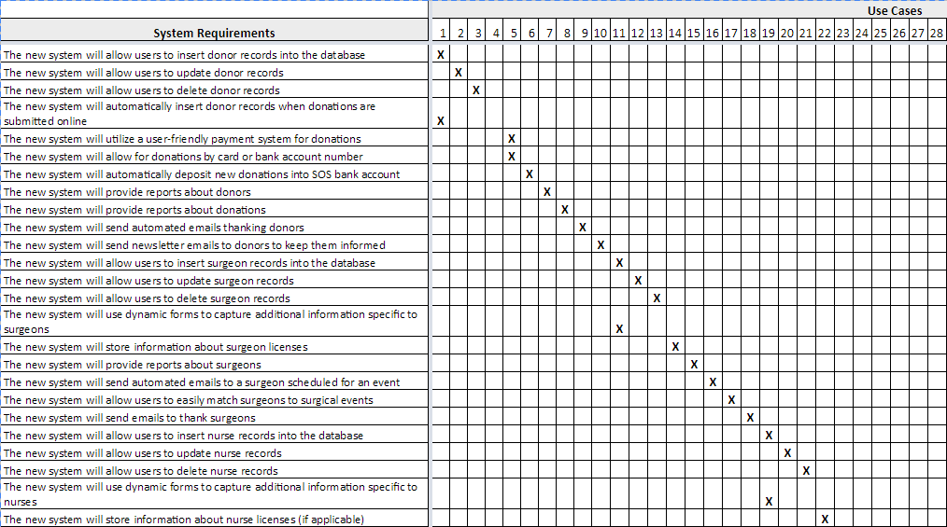The Trace Matrix displays how the Use Cases relate to the System Requirements.

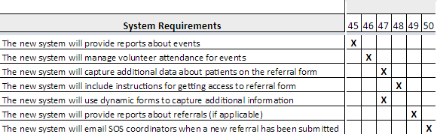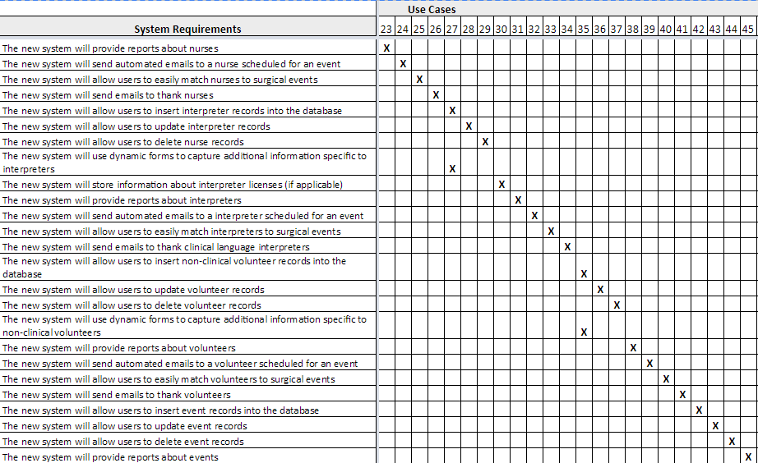

Initial Architecture Considerations

Initial architecture considerations provide descriptions and representations of system options from the design viewpoint and the realization viewpoint.

* 1. **Design Viewpoint**

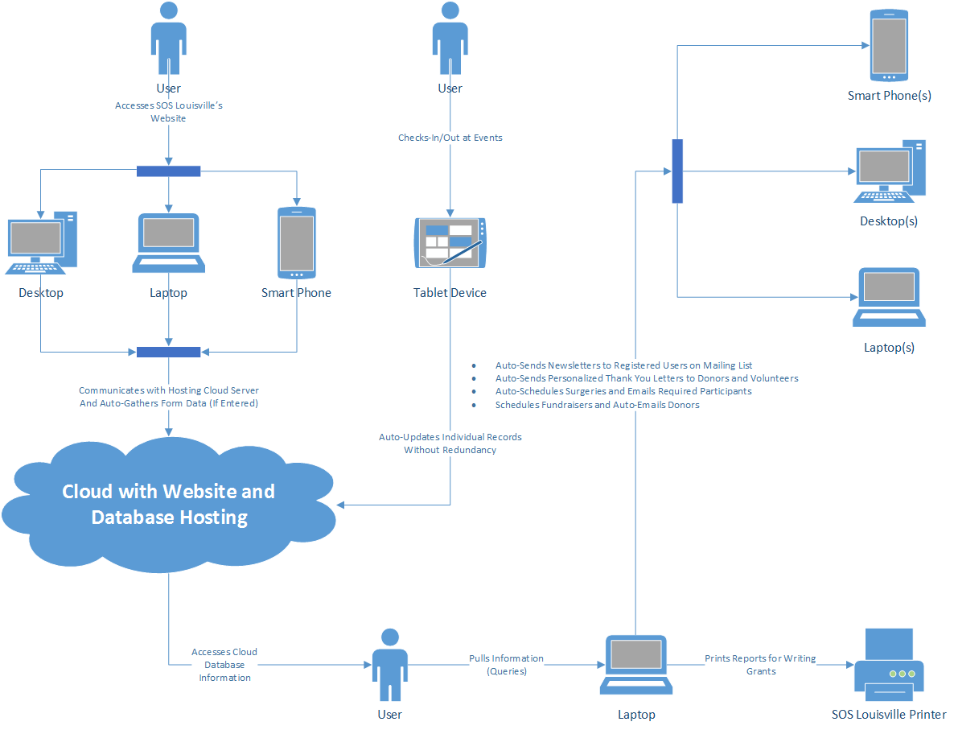

* 1. **Realization Viewpoint**

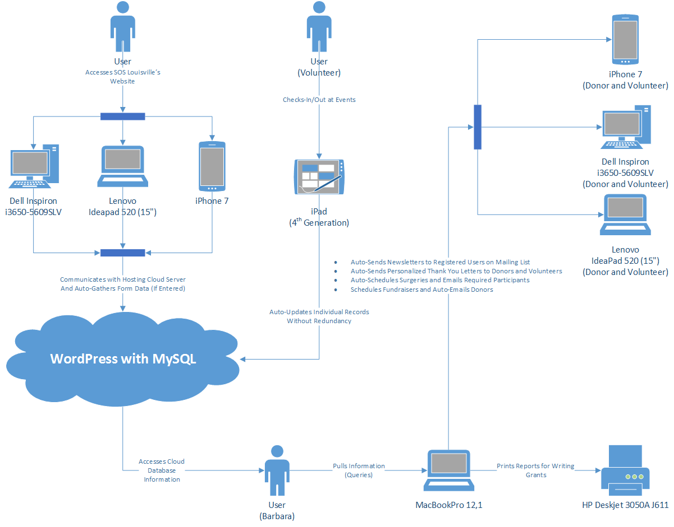

Risk Analysis

In this document, we assess the amount of risk involved if the system cannot complete the tasks stated.

A rating of “High” would mean that the risk involved with not completing that task within the system could be detrimental to the system and organization. “Medium” assessments are tasks that the system needs to complete, but including it is not as important as the “High” risk tasks. “Low” risk tasks are things that would be a nice added feature but are not considered a must have capability of the system.

**Criteria used to assess risk**: To assess the risk, we consider the amount of time and money the company could lose if the system could not complete these tasks. The more time the organization has, the more money they can earn, surgeries they can conduct, and volunteers they can acquire.

Team Charter

Team goals

* + We wish to design a system for SOS Louisville that fixes their current data management issues, saves them valuable time, and promotes the greater good in all that SOS does.
  + We wish to function as a coherent unit, with everyone putting forth an equal share of high quality work that attests to our professional commitments to SOS Louisville.
  + As a team, we seek to specifically address the following issues within SOS Louisville:
    - The indirect collection of volunteer information
    - The lack of payment options for donors
    - The underutilization of social media as a marketing tool
    - The inadequate and unclear “Events” page present on their current web site
    - The lack of donor tracking
    - The lack of integrated data storage
    - The manual retrieval of data for writing reports and scheduling events
    - The categorization of volunteers into categories that are too general to be useful
    - The underutilization of volunteer attendance data
    - The manual scheduling of events

Team meetings

* + The locations, dates, and times of team meetings will be decided on an as-needed basis (excluding pre-scheduled class meetings).
    - Meetings will be announced through text via groupme and upon majority consensus.
    - Because of everyone’s varying work and school schedules, it is difficult to schedule a recurring group meeting that can be attended by all members.
  + Most out-of-class group meetings will be virtual (using the Google Docs suite and possibly Skype)
    - Once again, this meets the group’s needs to be flexible and open to schedule changes at any given notice.
  + Decisions will be documented within our group via the GroupMe application, as well as by us individually at the time the group meetings take place.
    - The GroupMe app provides a public record for which team members are responsible for which tasks.
    - Our individual records provide a more detailed view, documenting the specific steps an individual must take to accomplish his or her goals within the group.

Team communications

* + Our primary means of communications will be discussions during class time.
    - This works out well for everyone because there are no class schedule conflicts, being that we are all enrolled in the same class.
    - Most of the class time is free for group work and discussions. Therefore, we usually have about 45 minutes to an hour to discuss current objectives and issues facing our group and client.
    - Although difficulty may arise if a member is sick or absent, the absent member can be filled in through our secondary means of communication via the GroupMe app.
  + Our secondary means of communications will be through texts via GroupMe. However, emails (both school and personal) may be used for the exchange of information and documents not yet posted to Google Docs.
    - Most out-of-class communications, as meetings, will be virtual in the sense that we will not all presently be in the same location.
    - This allows flexibility of response time, as well as a wider range of available meeting locations and dates.

Team decisions

* + The team will hear the opinions of every group member and accept a decision upon majority consensus.
    - We look to include every group member and to facilitate civil discussion about our client and the issues currently facing the group.
    - This provides a list of choices, allowing us to reach a majority consensus on the choice that best suits our current problems.
  + In the event that conflicts arise from the decisions made, the dissenting group member may appeal the issue to the group via discussion (either vis-a-vis or virtually over GroupMe and the like).
    - In the event that the issue persists, the majority of the group and/or the dissenting member may contact Dr. Barker for mediation, allowing him to facilitate civil discussion and to settle on a feasible compromise.
  + In the event that a group member is no longer putting forth his or her fair share of work or effort, the group has the right to confront said member and discuss the issue in an effort to maintain team coherence and inclusion.
    - As per conflict, if the issue persists, the group may contact Dr. Barker to discuss the removal of said group member.

Project repository

* + The team will maintain project documentation via the Google Docs suite. All deliverables and team documents will be loaded and shared here as to maintain uninterrupted access allowing us to work coherently but also individually.
    - Flexibility is an important aspect for our team and the Google Docs suite is accessible 24/7 (barring a blackout of Google services), which allows the group to work on team deliverables at all hours and without needing access to another group member’s personal storage.
  + Each team member is responsible for documenting his or her own involvement as well as the involvement of other members in the event that there are conflicting accounts of group member involvement.
    - This allows each group member to keep documentation of his or her current efforts, while being checked by independent documentation in the event that a conflict arises.

Gantt Chart

The Gantt chart determines the tasks of a project and how long each task will take as well as task dependencies.

*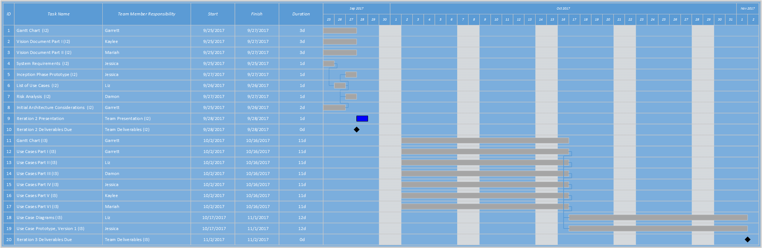[Below the proceeding image are zoomed in excerpts of the photo for better readability.]*

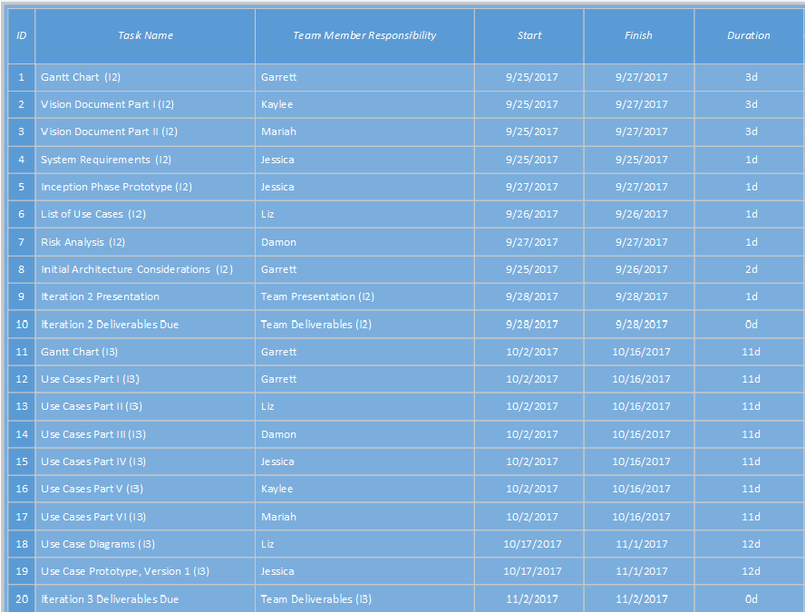

Inception Phase Prototypes

Inception phase prototypes are high-level prototypes that represent the data needs and process flows of the “to-be” business processes, with a focus on high-risk use cases.

**1. Dynamic Volunteer Form**

Instead of using a dropdown that points to different volunteer forms, we envision one dynamic form. This will simultaneously declutter the website, provide a sleek user experience, and capture only the information that is necessary for each type of volunteer.

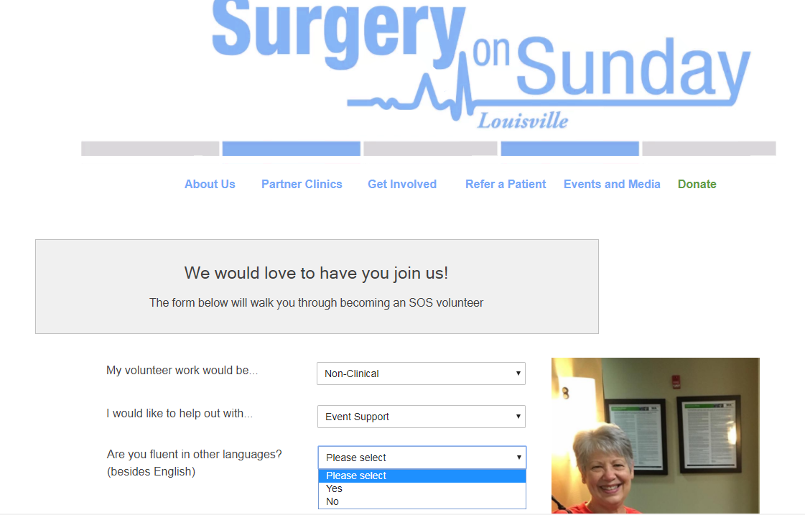

**2. Events/Media Page**

The new Events page will also feature past events and possibly embedded social media posts that tag Surgery on Sunday. Here, we would include testimonials, success stories, and news articles about SOS.

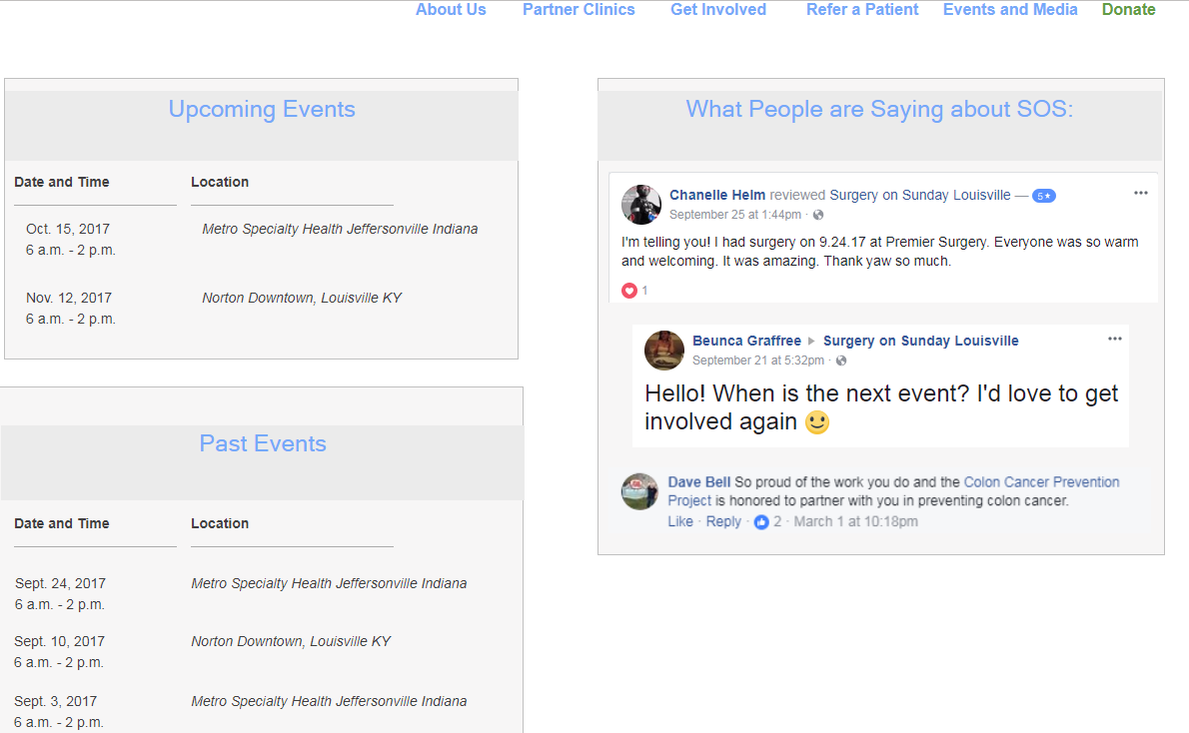

**3. Braintree Donations**

Our team recommends that the client switch from PayPal to Braintree. We will introduce the donor to a warm webpage that invites and inspires them to become a part of something exciting. Happy photos and possibly quotes from real SOS patients will assure donors that they are making a difference.

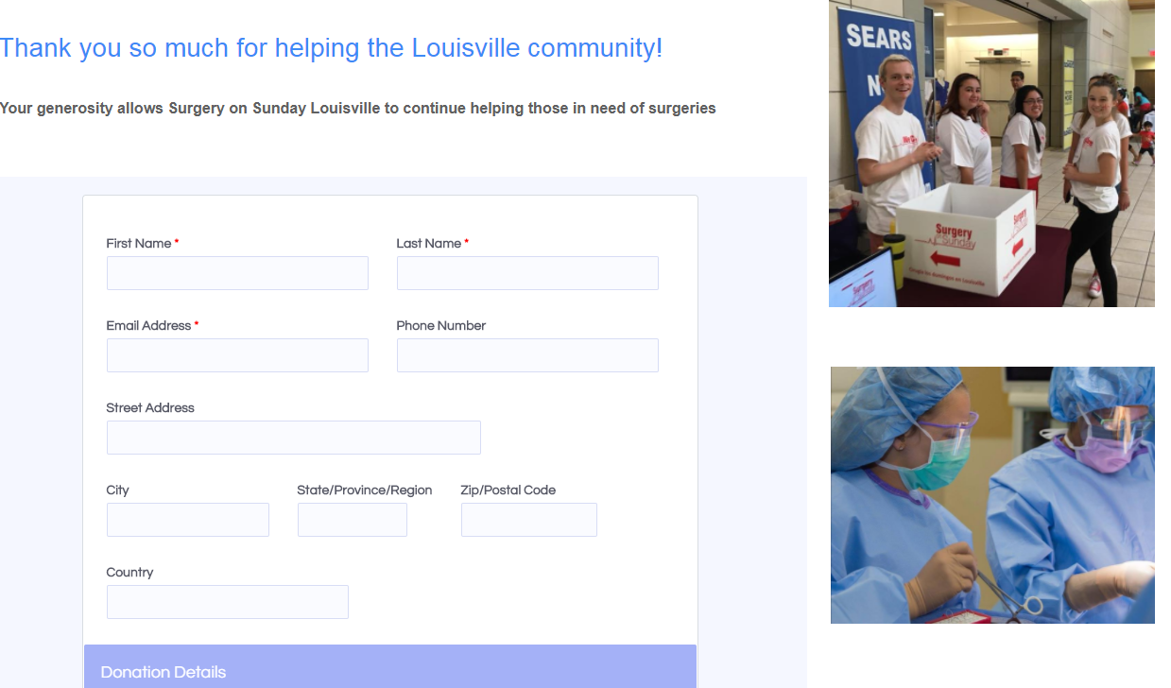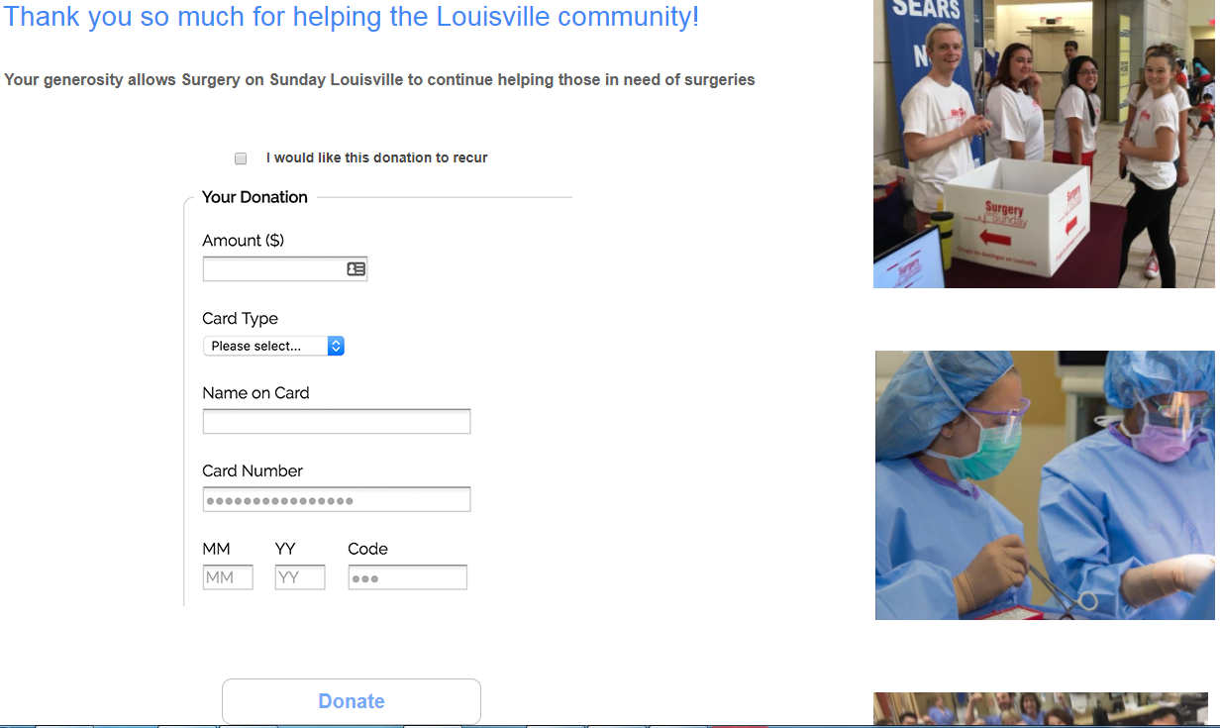

**4. Homepage**

Although not a high-risk deliverable, the homepage would benefit from an easy cleanup and design enhancement. This is the page users first see when they navigate to the website, so it should inspire them to donate, volunteer, or spread the word about SOS.

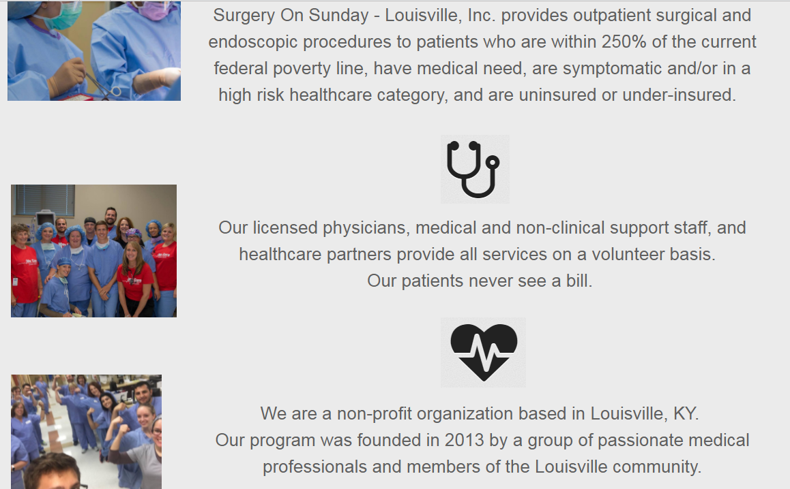

**5. Administration Portal**

We envision a centralized portal for SOS staff and coordinators to schedule surgeries, events, run reports, and manage SOS data without needing to frequently access the MySQL database directly.

